**Metrology TESTS – Grating Substrate S5**

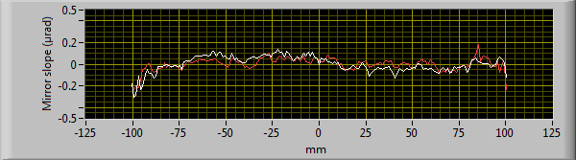

***Figure : 1D central line of Residual slope error***

The difference between scan A to B and scan B to A is 26 nrad rms on the central line.

**Average give over 12 x 200 mm2**

Scan a : R = -139km, 84 nrad rms over 200mm

Scan b : R = -145km, 62 nrad rms over 200mm



***Figure : 1D central line of Residual slope error***



***Figure : 2 D map of Residual slope error***

**OK over 200 mm…**

***Figure : 1D central line of Residual Height error (after integration)***



***Figure : 2 D map of Residual Height error (after integration)***